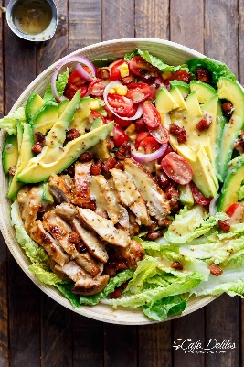
Honey Mustard Chicken Salad With Bacon & Avocado

Ingredients
For Salad:
1/4 cup diced bacon, trimmed of rind and fat
4 cups Romaine lettuce leaves, washed
1 cup sliced grape or cherry tomatoes
1 large avocado, pitted and sliced
1/4 cup corn kernels
1/4 of a red onion, sliced

Dressing / Marinade:
1/3 cup honey
3 tablespoons whole grain mustard
2 tablespoons smooth and mild Dijon mustard
2 tablespoons olive oil
1-2 tablespoons Apple cider vinegar (or white vinegar)
1 teaspoon minced(gehakte) garlic
Salt to season
4 chicken breast
Instructions
Whisk marinade / dressing ingredients together to combine. Pour half the marinade into a shallow dish to marinade the chicken fillets for two hours if time allows. Refrigerate the reserved untouched marinade to use as a dressing.
Heat a nonstick pan (or grill pan or skillet) over medium heat with about a teaspoon of oil and sear / grill chicken fillets on each side until golden, crispy and cooked through. (Grill in batches to prevent excess water being released.) Once chicken is cooked, set aside and allow to rest.
Wipe pan over with paper towel; drizzle with another teaspoon of oil and fry the bacon until crispy.
Slice chicken into strips and prepare salad with leaves, tomatoes, avocado slices, corn, onion strips and chicken.
Nutrition
Calories: 410kcal | Carbohydrates: 34g | Protein: 25g | Fat: 20g | Saturated Fat: 3g | Cholesterol: 108mg | Sodium: 357mg | Potassium: 782mg | Fiber: 5g | Sugar: 25g | Vitamin A: 4375IU | Vitamin C: 16.3mg | Calcium: 47mg | Iron: 2.3mg

Whisk 2 tablespoons of water into the remaining untouched marinade / dressing and drizzle over the salad. Sprinkle the bacon over the top and season with a little extra salt and cracked pepper (optional).

